|  |  |  |
| --- | --- | --- |
| **MOBILE APPLICATION DEVELOPMENT**  **(Effective from the academic year 2018 -2019)**  **SEMESTER** - **VI** | | |
| **Course Code** | **18CSMP68 IA Marks** | 40 |
| **Number of Contact Hours/Week** | 0:0:2 **Exam Marks** | 60 |
| **Total Number of Contact Hours** | 3 Hours/Week **Exam Hours** | 03 |
| **CREDITS-02** | | |
| **Laboratory** Objectives:Thisla boratory (18CSMP68) will enable students to | | |
| * Learn and acquire the art of Android Programming. * ConfigureAndroid studio to run the applications. * Understand and implement Android's User interface function s. * Create, modify and query on SQlite database. * Inspect different methods of sharing data usin g services. | | |
| **Descriptions (if any):** | | |
| 1. The installation procedure of the Android Studio/Java software must be demonstrated and carried   out in groups.   1. Students should use the latest version of Android Studio/Java/ Katlin to execute these programs . Diagrams given are for representational purposes only, students are expected to improvise on them. 2. **Part B programs should be developed as an application and are to be demonstrated as a mini project in a group by adding extra features or the students can also develop their application and demonstrate it as a mini-project. (Projects/programs are not limited to the list given in Part B).** | | |

I Programs List:

I **PART-A**

|  |  |
| --- | --- |
| **1** | Create an application to design aVisiting Card. The Visiting card should havea companylogoatthe  top right comer. The company name should be displayed in Capital letters, aligned to the center. Information like the name of the employee, job title, phone number, address, email, fax and the website address isto be displayed . Insert a horizontal line between the job title and the phone number. |
| **2** | Develop an Android application usingcontrols like Button, TextView, EditText for designing a  calculatorhaving basic functionality like Addition, Subtraction, Multiplication,andDivision. |

|  |  |
| --- | --- |
|  |  |
| 3 | Create a SIGN Up activity with Username and Password. Validation of password should happen  based on the following rules:   * Password should contain uppercase and lowercase letters. * Password should contain letters and numbers. * Password should contain special characters. * Minimum length of the password (the default value is 8).   On successful **SIGN UP** proceed to the next Login activity. Here the user should **SIGN IN** using the Username and Password created during signup activity. If the Username and Password are matched then navigate to the next activity whichdisplays a message saying "Successful Login" or else display a toast message saying "Login Failed".The user is given only two attempts and after thatdisplay a toast message saying " Failed Login Attempts" and disable the SIGN IN button. Use Bundle to transfer information from one activity to another. |

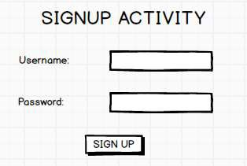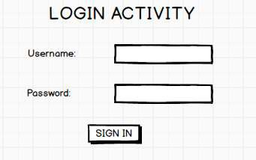

|  |  |
| --- | --- |
| **4** | Develop an application to set an image as wallpaper. On click of a button, the wallpaper image  should start to change randomly every 30 seconds. |
| **5** | Write a program to create an act1V1ty with two buttons START and STOP. On  pressingoftheSTART button, the activity must start the counter by displaying the numbers from One and the counter must keep on counting until the STOP button is pressed. Display the counter value in a TextViewcontrol. |
| **6** | Create two files of XML and JSON type with values for City_Name, Latitude, Longitude,  Temperature,andHumidity. Develop an application to create an activity with two buttons to parse the XML and JSON files which when clicked should display the data in their respective layouts side by side. |

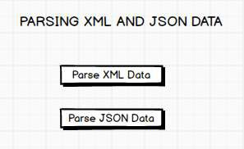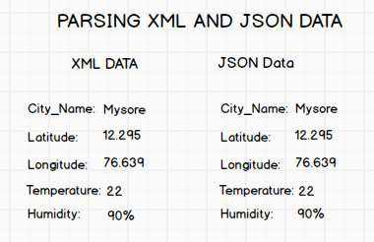

|  |  |
| --- | --- |
| 7 | Develop a simple application withoneEditTextso that the user can write some text in it. Create a  button called "Convert Text to Speech" that converts the user input text into voice. |
| **8** | Create an activity like a phone dialer withCALLand SAVE buttons. On pressing the CALL  button, it must call the phone number and on pressing the SAVE button it must save the number to the phone contacts. |
| **PART-B** | |
| **1** | Write a program to enter Medicine Name, Date and Time of the Day as input from the user and  store it in the SQLite database. Input for Time of the Day should be either Morning or Afternoon or Eveningor Night. Trigger an alarm based on the Date and Time of the Day and display the Medicine Name. |

|  |  |
| --- | --- |
| **2** | Develop a content provider application with an activity called "Meeting Schedule" which takes  Date, Time and Meeting Agenda as input from the user and store this information into the SQLite database. Create another application with an activity called "Meeting Info" having DatePicker control, which on the selection of a date should display the Meeting Agenda information for that particular date, else it should display a toast message saying "No Meeting on this Date". |
| **3** | Create an application to receive an incoming SMS which is notified to the user. On clicking this  SMS notification, the message content and the number should be displayed on the screen. Use appropriate emulator control to send the SMS message to your application. |
| **4** | Write a program to create an activity having a Text box, and also Save, Open and Create buttons.  The user has to write some text in the Text box. On pressing the Create button the text should be saved as a text file in MkSDcard. On subsequent changes to the text, the Save button should be pressed to store the latest content to the same file. On pressing the Open button, it should display the contents from the previously stored files in the Text box. If the user tries to save the contents in the Textbox to a file without creating it, then a toast message has to be displayed saying "First Create a File". |

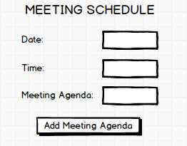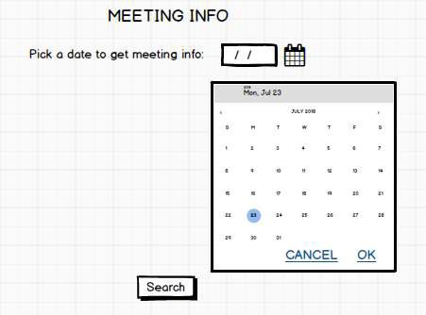

|  |  |
| --- | --- |
|  |  |
| **5** | Create an application to demonstrate a basic media playerthat allows the user to Forward,  Backward, Play and Pause an audio. Also, make use of the indicator in the seek bar to move the audio forward or backward as required. |
| **6** | Develop an application to demonstrate the use of Asynchronous tasks in android. The  asynchronous task should implement the functionality of a simple moving banner. On pressing the **Start Task** button, the banner message should scrollfrom right to left. On pressing the **Stop Task** button, the banner message should stop.Let the banner message be "Demonstration of Asynchronous Task". |
| **7** | Develop an application that makes use of the clipboard framework for copying and pasting of the  text. The activity consists of two EditText controls and two Buttons to trigger the copy and paste functionality. |

|  |  |
| --- | --- |
|  |  |
| **8** | Create an ATDL service that calculates Car Loan EMT. The formula to calculate EMT is  **E** = **P * (r(l+r)")/((l+r)"-1)**  where  E = The EMI payable on the car loan amount P = The Car loan Principal Amount  r = The interest rate value computed on a monthly basis n = The loan tenure in the form of months  The down payment amount has to be deducted from the principal amount paid towards buying the Car. Develop an application that makes use of this AIDL service to calculate the EMI. This application should have four EditText to read the PrincipalAmount, Down Payment, Interest Rate, Loan Term (in months) and a button named as "Calculate Monthly EMI". On click of this button, the result should be shown in a TextView. Also, calculate the EMT by varying the Loan Term and Interest Rate values. |
|  |  |
| **Laboratory Outcomes:After** studying theselaboratory programs, students will be able to | |
| * Create, test and debug Android application by setting up Android development environment. * Implement adaptive, responsive user interfaces that work across a wide range of devices. * Infer long running tasks and background work in Android applications. * Demonstrate methods in storing, sharing and retrieving data in Android applications. | |

I

|  |
| --- |
| * Infer the role of permissions and security for Android applications. |
| **Procedure to Conduct Practical Examination** |
| * Experiment distribution   + For laboratories having only one part: Students are allowed to pick oneexperiment from the lot with equal opportunity.   + For laboratories having PART A and PART B: Students are allowed to pick oneexperiment from PART A and one experiment from PART B, with equalopportunity. * Change of experiment is allowed only once and marks allotted for procedure to be made zero of the changed part only. * Marks Distribution (Courseed to change in accordance with university regulations)   + For laboratories having only one part - Procedure + Execution + Viva-Voce: 15+70+15= 100 Marks   + For laboratories having PART A and PART B     1. Part A - Procedure+ Execution+ Viva= 6 + 28 + 6 = 40 Marks     2. Part B - Procedure+ Execution+ Viva= 9 + 42 + 9 = 60 Marks |
| **Text Books:** |
| 1. Google Developer Training, **"Android Developer Fundamentals Course - Concept**  **Reference",** Google Developer Training Team, 2017.  https://[www.gitbook.com/book/google-developer-training/and roid-developer-fundamentals­](http://www.gitbook.com/book/google-developer-training/android-developer-fundamentals) course-concepts/detai Is  (Download pdf file from the above link) |
| **Reference Books:** |
| 1. Erik Hellman, **"Android Programming - Pushing the Limits",** 1st Edition, Wiley India Pvt Ltd,   2014. ISBN-13: 978-8126547197   1. Dawn Griffiths and David Griffiths, **"Head First Android Development",** 1st Edition, O'Reilly SPD Publishers, 2015. ISBN-13: 978-9352131341 2. Bill Phillips, Chris Stewart and Kristin Marsicano, **"Android Programming: The Big Nerd Ranch Guide",** 3rd Edition, Big Nerd Ranch Guides, 2017. ISBN-13: 978-0134706054 |

I